**Sitemap Stage**

“Hey [Client Name],

Hope you’re doing great.

Now that we have all the details we need to get started, I created a “Sitemap” for our project.

This stage lists out all the components of the website so that we can agree on what we will be building.

Click here to access it: [Insert URL to client’s site or development environment]

I installed a visual collaboration system on your website that will allow us to communicate smoothly and save a lot of time through the process.

Simply click the + icon on the right side of the screen to choose any part of the sitemap to leave a request.

The messages will go directly to me so I can take action on the requests.

If you want to learn a little more about it, here’s a short video: https://www.youtube.com/watch?v=PtTHZgRdK5A&ab_channel=WPFeedBack

I would like to build momentum as we’re going through the project, so please go through this page today or tomorrow the latest (Estimated 5-10 minutes of your time).

Let me know if you have any questions”

**Wireframe/Prototype Stage (Collect Content)**

“Hey [Client Name],

Hope you’re doing great.

I’ve finished creating the wireframes for the project.

Wireframes are the blueprints of the website. After this stage is complete we will move to the development and design stage of the project.

On this stage, I’d like you to go through the pages and let me know if there’s anything we missed on the layout (the structure of the pages).

Also, this is our opportunity to collect the content that will be displayed on different pages.

I added placeholder text on all the titles and text blocks.

Please use the visual collaboration system to add the content throughout the site.

Like before, simply click the + icon on the right side of the screen to choose any part of the page to attach a message.

If you want to learn a little more about it, here’s a short video: https://www.youtube.com/watch?v=PtTHZgRdK5A&ab_channel=WPFeedBack

Click here to access the home page: [Insert URL to client’s site or development environment]

I’ve allocated 2 days and the weekend for you to go through and provide the required feedback and content (Estimated 2 hours of your time).

Once this stage is done, we’ll start the development and design stage.

Let me know if you have any questions”

**Design Approval Stage**

“Hey [Client Name],

Hope you’re doing great.

The design is ready for your approval!

As we’re approaching the end of the project, I’d like you to go through the pages and let me know if there’s anything we missed on the design or anything needs changing.

If you get inspired with additional requests at this stage, please note them down. We might include them, or make a list of requests that will add at a later date, if out of scope.

Please use the visual collaboration system to add your notes throughout the site.

Simply click the + icon on the right side of the screen to choose any part of the page to attach a message.

If you want to learn a little more about it, here’s a short video: https://www.youtube.com/watch?v=PtTHZgRdK5A&ab_channel=WPFeedBack

Click here to access the newly designed home page: [Insert URL to client’s site or development environment]

I allocated 2 revision rounds for this stage, each “revision round” is defined by 2 days and a weekend, like before (Estimated 1 hour of your time).

Once this stage is done, we can launch the website!

Let me know if you have any questions”

**Launch + Care Plans Stage**

“Hey [Client Name],

Hope you’re doing great.

The website is now live!

Use these logins to connect to your new website:

Username: [client username] Password: [client password]

From your phone, please click on this link and save it to your phone’s home screen.

Andriod: Tap the menu button and tap Add to home screen.

Apple: Tap the Share button on the browser’s toolbar and tap the Add to Home Screen icon.

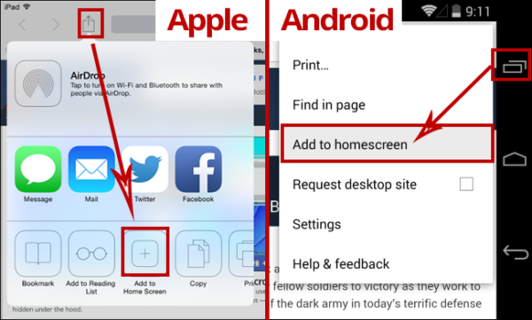

This will give you direct access to your website as well as reach out to me if you need anything.

Simply click the + icon on the right side of the screen to choose any part of the page to attach a message.

You can also open the feedback sidebar (below the + icon) and click the “General” button to make generic requests that are not about a specific part of the page.

Click here from your phone: [Insert URL to the client’s site that includes the login parameter]

Congratulations!

Let me know if you have any questions”